**ISKOlarly**

**User’s**

**Manual**

**TABLE OF CONTENTS**

**PAGE**

**INSTRUCTOR MODULE 1**

Creating an account 1

Adding a course 2

Creating posts or announcements, quizzes, and attachments 4

Creating questionnaires 9

Checking of reports 13

**STUDENT MODULE 18**

Creating an account 18

Joining a course 19

Creating posts or announcements 21

Taking a quiz 24

**LIST OF DEPENDENCIES**

**FOR localhost:**

1. **Node version 9.x.x (for BCrypt support)**
2. **npm package manager –** used to install packages and dependencies to make the web application locally available
3. **Redis Server and Redis Client –** used for session handling and storing
4. **MySQL –** the RDBMS used for the schema for the web application
5. **R-Base (R programming language) –** the programming language used for the implementation of the pattern mining of the web application
6. **Modern web browsers and their latest updates –** this dependency is considered to make sure that the web application will run smoothly.

**FOR DEPLOYED WEB APPLICATION**

* NOTHING but a latest web browser to support and use the full functionality of the web application

1. **Instructor Module**
2. 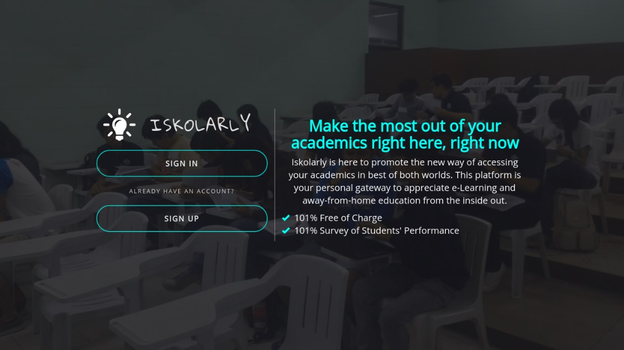Creating an account

**Step 1**: Click on the  
 **Sign up** button.

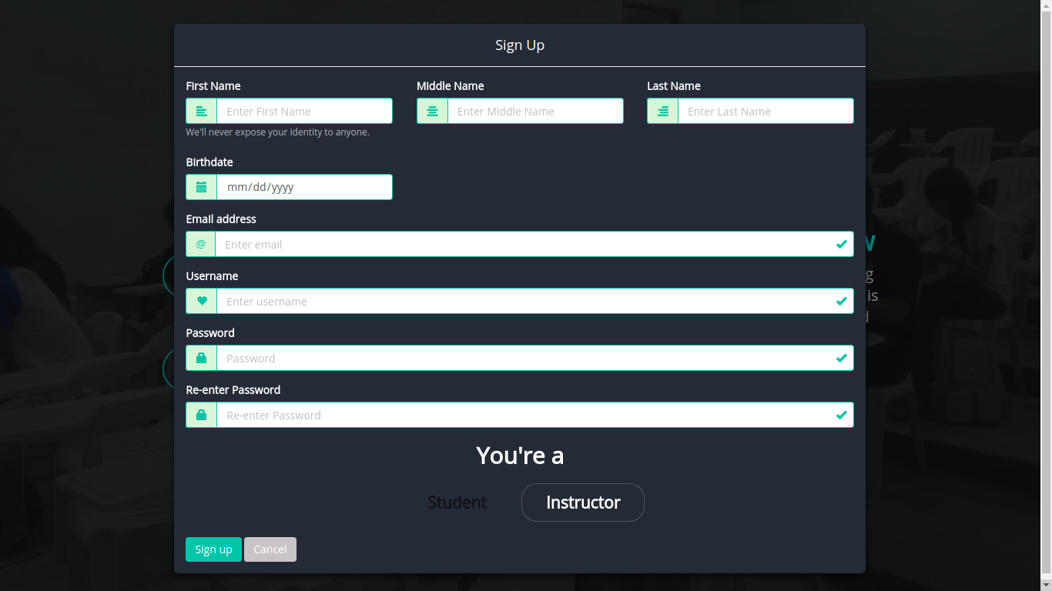

**Step 2**: Select as   
**Instructor** and  
fill up the form.

**Step 3**: Click the  
**Sign up** button.

1. Adding a course

**Step 1**: Click on the  
 **Sign in** button.

**Step 2**: Fill up the form using valid credentials.

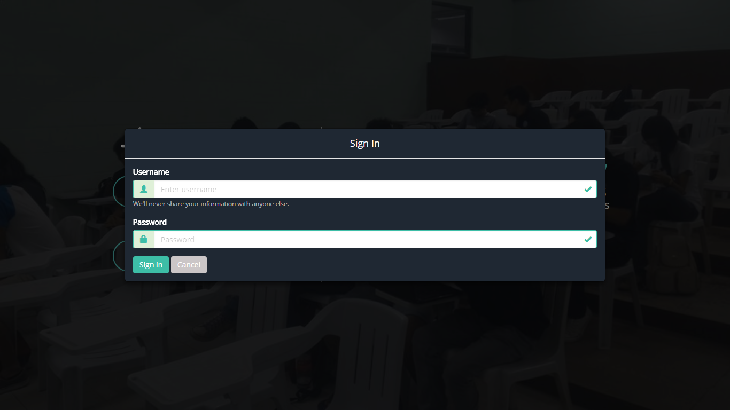

**Step 3**: Click the  
**Sign in** button.

**Step 4:**  
Go to the **Course** menu.

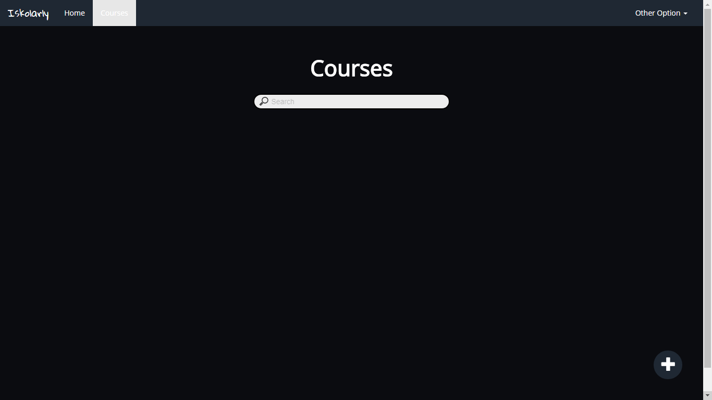

**Step 5**: Click the  
**Add icon** button.

**Step 6**: Fill up the form.

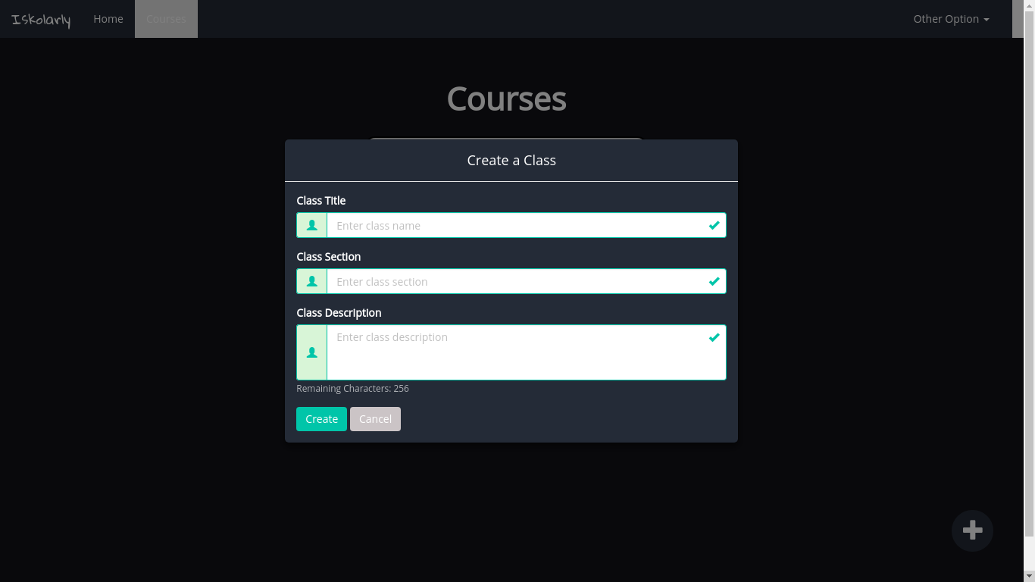

**Step 7**: Click the  
**Create** button.

1. Creating posts or announcements, quizzes, and attachments

**Step 1**: Click on the  
 **Sign in** button.

**Step 2**: Fill up the form using valid credentials.



**Step 3**: Click the  
**Sign in** button.

Assuming that classroom is created. There are two ways to access the classroom; home menu and course menu.

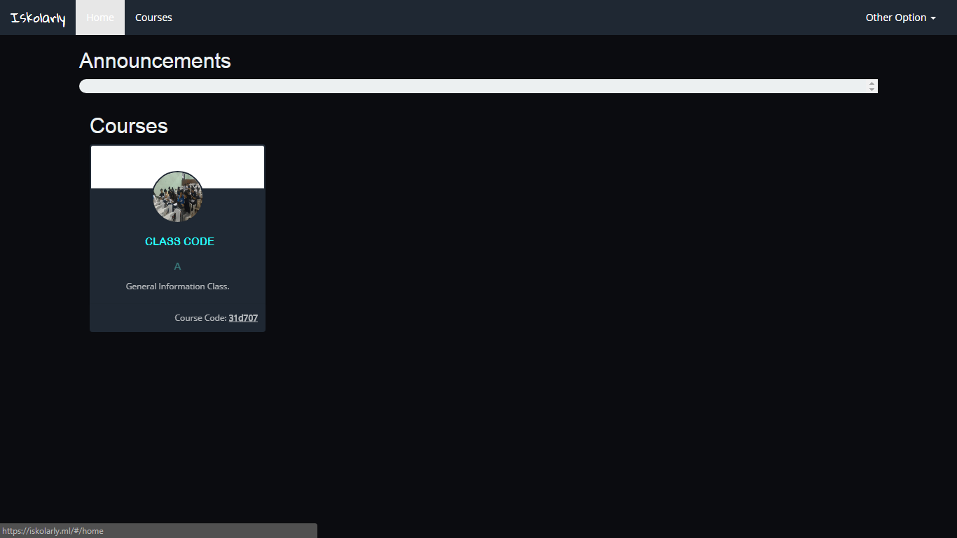

**Step 4**: Click the  
classroomin home page.

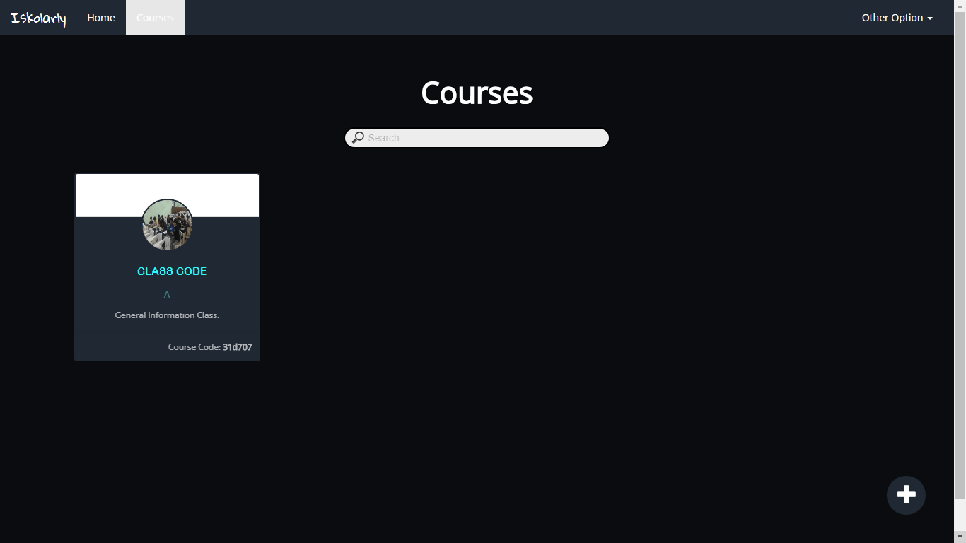

**Step 4:**  
Go to the **Course** menu and click the classroom.

Steps in creating posts and announcements.

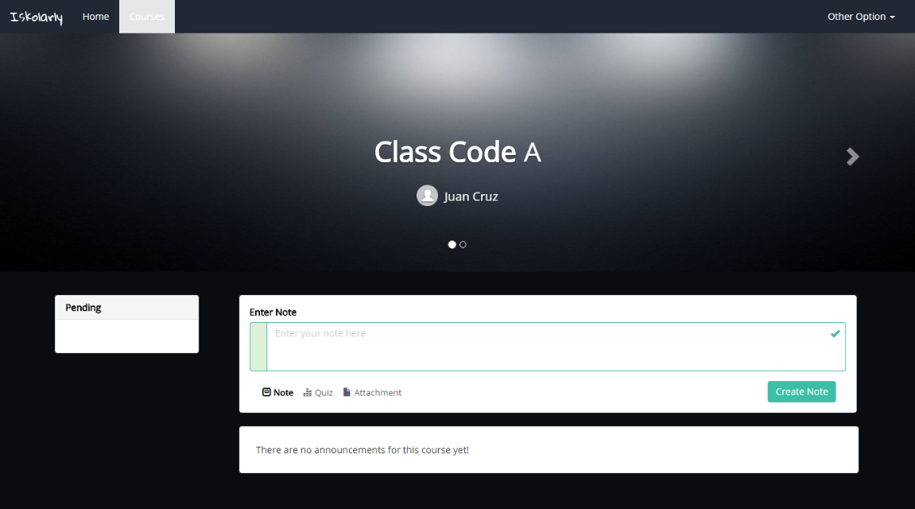

**Step 6**:   
Fill out the field.

**Step 5**:  
Click the **Note**.

**Step 7**: Click the  
**Create note** button.

Steps in creating attachments.



**Step 5**:  
Click the **Attachments**.

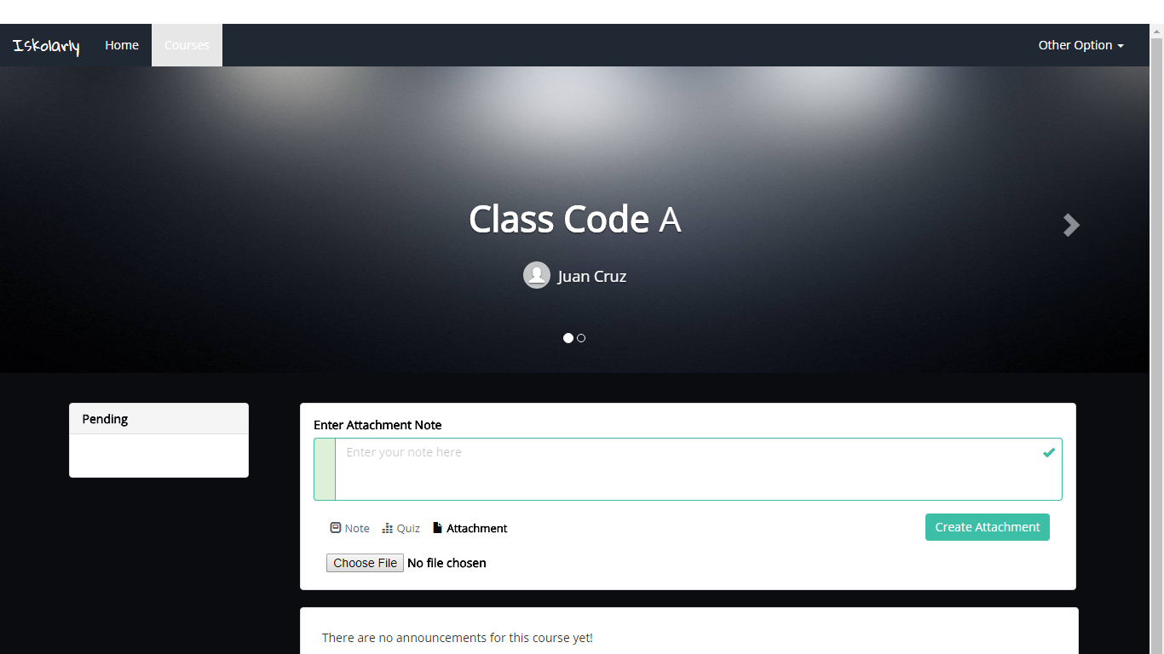

**Step 6**:   
Fill out the field.

**Step 8**: Click the  
**Create attachment** button.

**Step 7**:  
Click the **Choose file** button.

Steps in creating quizzes.

**Step 5**:  
Click the **Quiz**.

**Step 6**:   
Fill out the field.

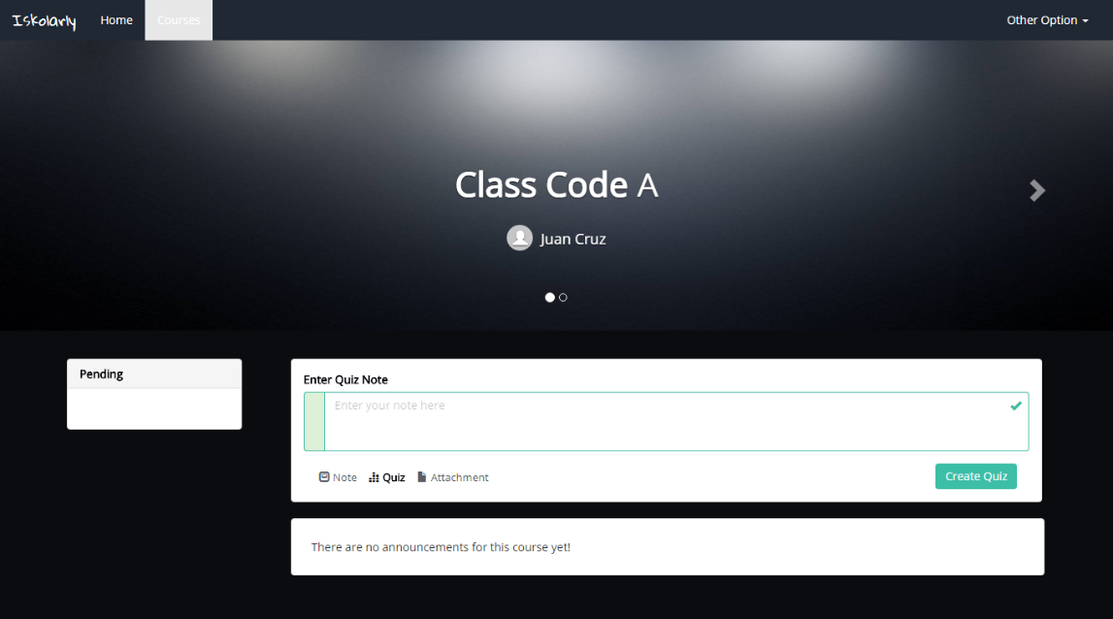

**Step 7**: Click the  
**Create quiz** button.

**Step 8**: Fill up the form.

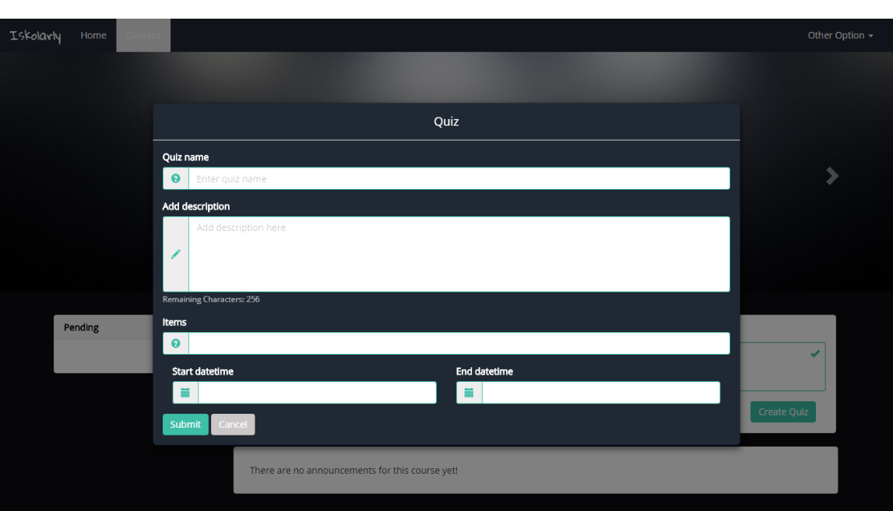

**Step 9**: Click the  
**Submit** button.

1.  Creating questionnaires

**Step 1**: Click on the  
 **Sign in** button.

**Step 2**: Fill up the form using valid credentials.



**Step 3**: Click the  
**Sign in** button.

Assuming that classroom is created. There are two ways to access the classroom; home menu and course menu.



**Step 4**: Click the  
classroomin home page.



**Step 4:**  
Go to the **Course** menu and click the classroom.

**Step 5:** Assuming that quiz is created. Click the quiz post.

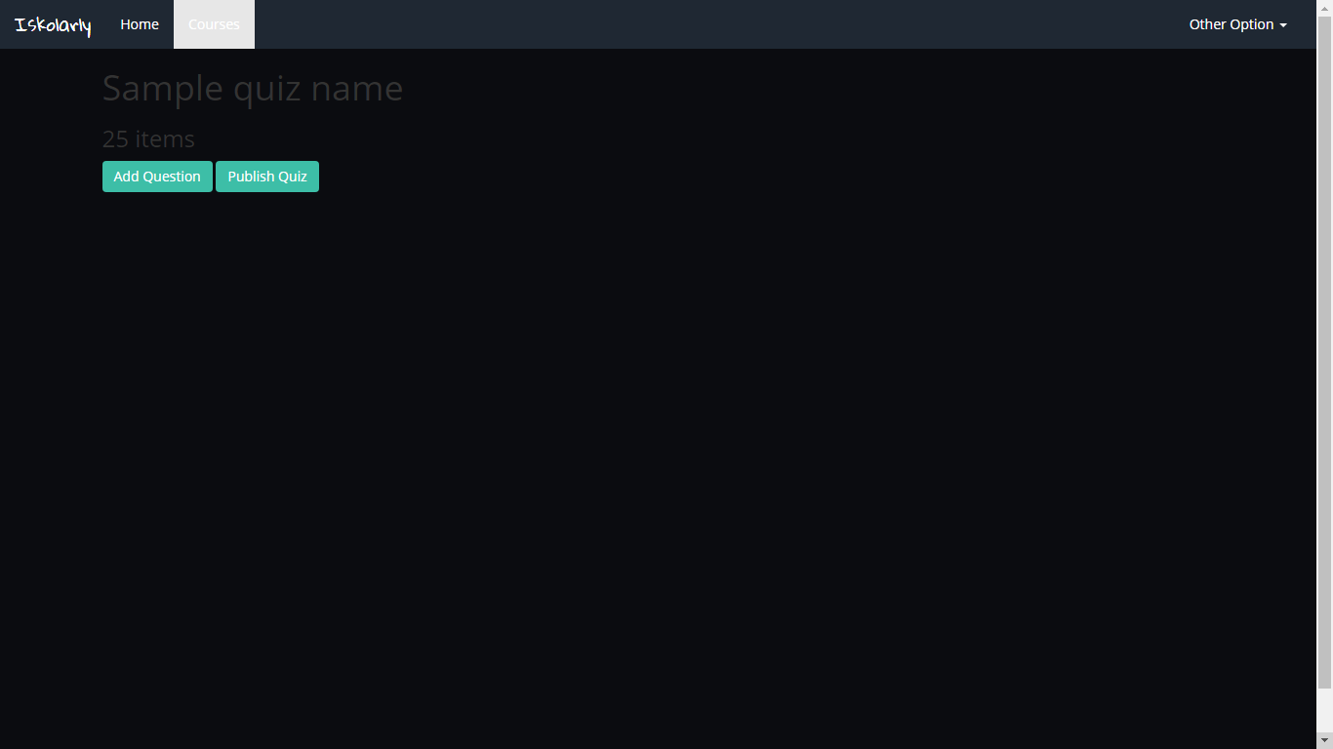

**Step 6:** Click the **Add question** button.

**Step 8**:  
Fill the question field.

**Step 7**: Choose whether the choices are  
plain text or images.

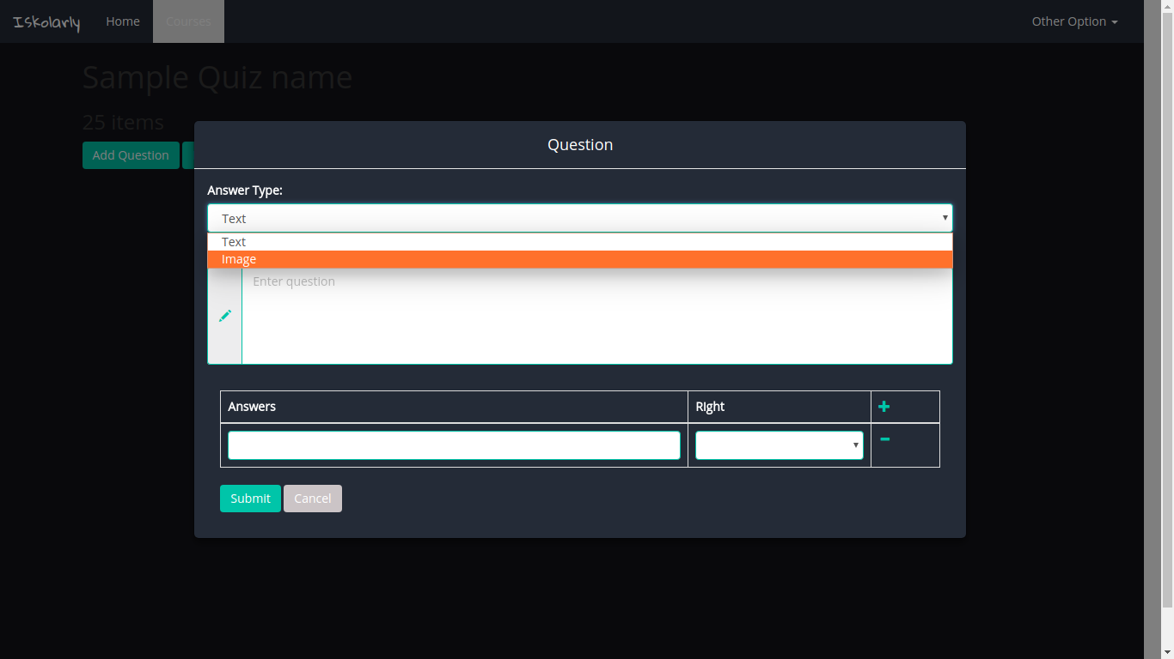

**Step 10**: Click the  
**Submit** button.

11

**Step 9**: Fill the answer field.  
Click the **add icon** to add another answer field.

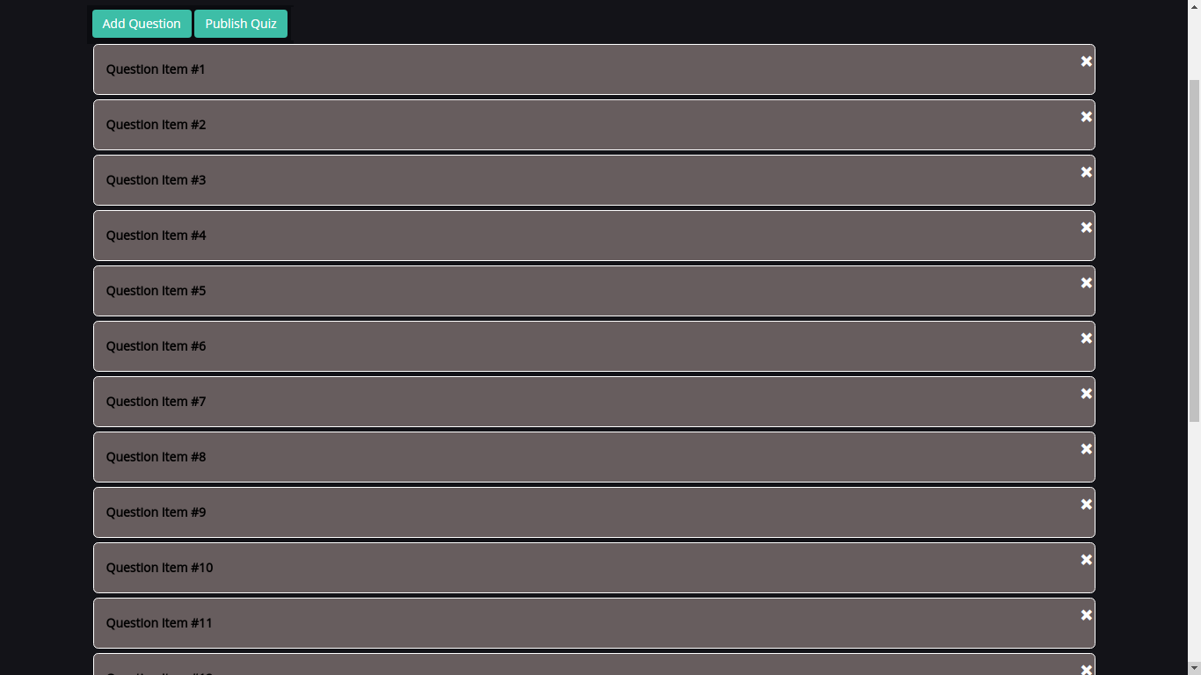

**Step 11:** Click the **Publish Quiz** button.

**Step 12**: Fill up the form.

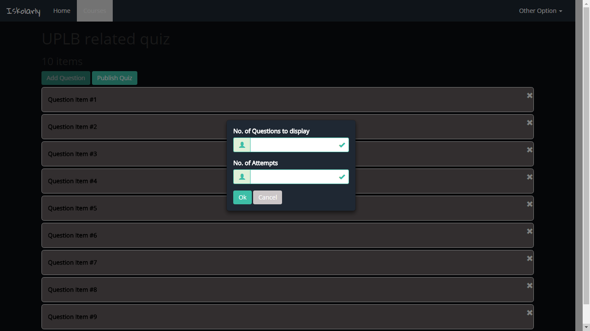

**Step 13**: Click the  
**Ok** button.

1. Checking of reports

**Step 1**: Click on the  
 **Sign in** button.

**Step 2**: Fill up the form using valid credentials.



**Step 3**: Click the  
**Sign in** button.

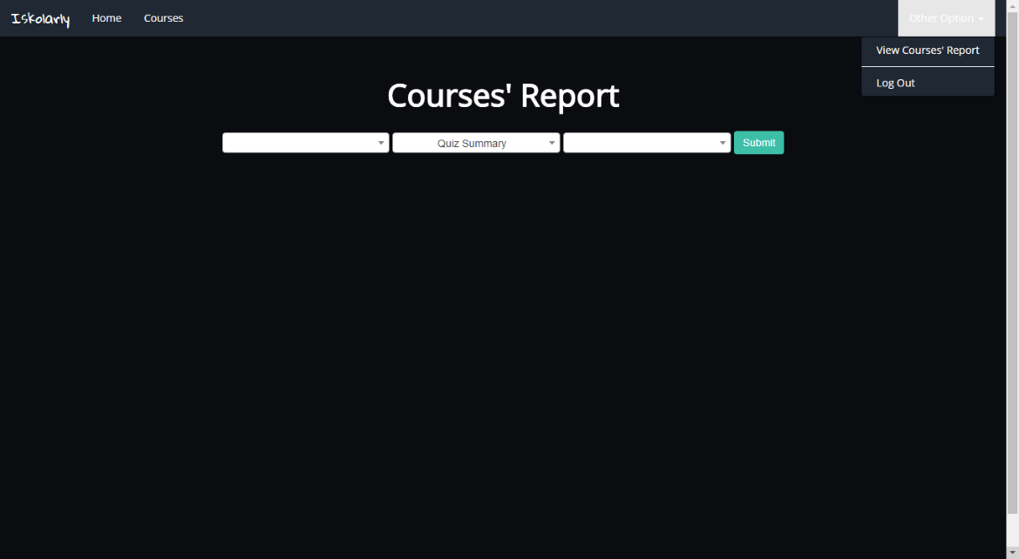

**Step 3:** Go to **Other options**. Click **View Course’s Report**.

For Quiz Summary Report.

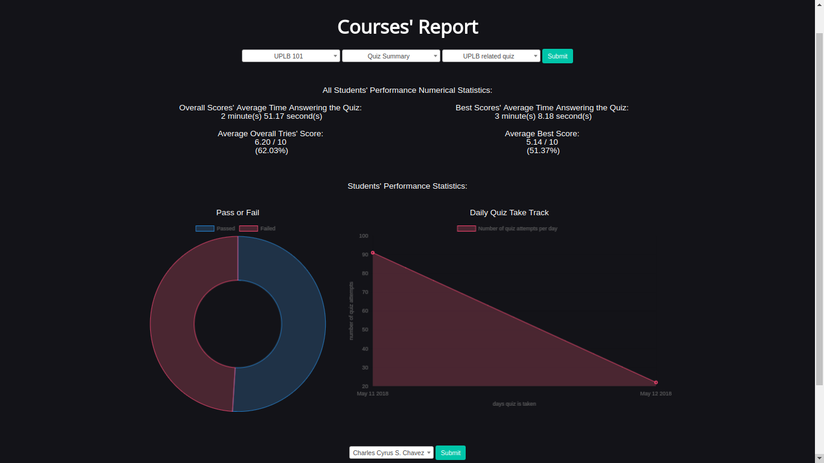

**Step 7**: Click the  
**Submit** button.

**Step 4:** Select Quiz Summary.  
**Step 5:** Select in the course.  
**Step 6:** Select the quiz name.



**Step 8**:   
Select student.

**Step 9**: To check the individual performances of students, click the  
**Submit** button.

For Activity Log of Finished Quizzes Report.

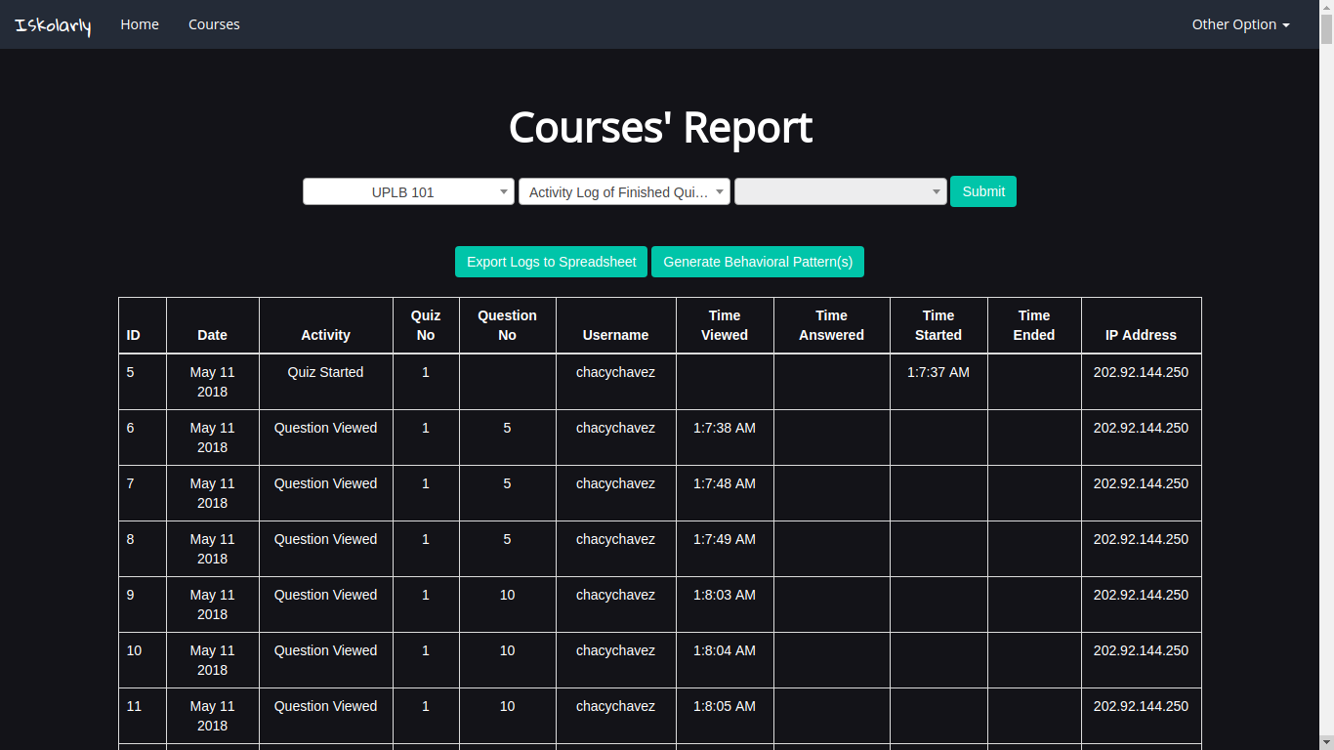

**Step 4:** Select Quiz Summary.  
**Step 5:** Select in the course.

**Step 6**: Click the  
**Submit** button.



**Step 7:** To check behavioral patterns, click the **Generate Behavioral Pattern.**

**Step 9:** To export the activity logs, click the **Export logs in spreadsheet.**

A modal will pop-up after clicking the **Generate Behavioral Pattern.**

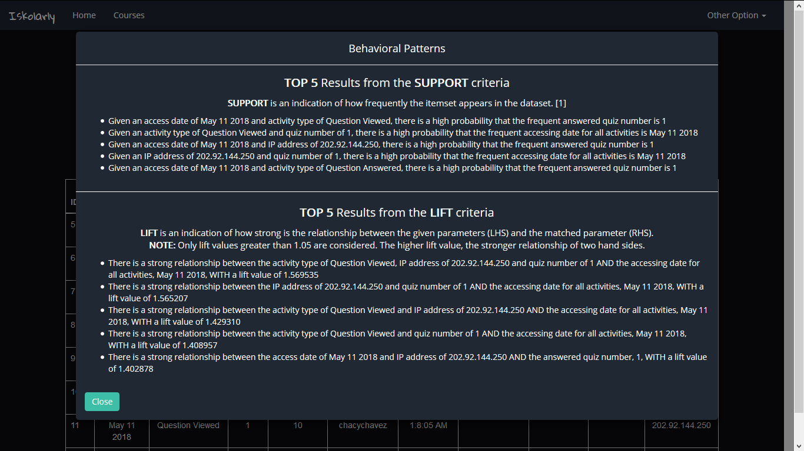

**Step 8:**Click the **Okay** button**.**

For Scores for All Quizzes Report.

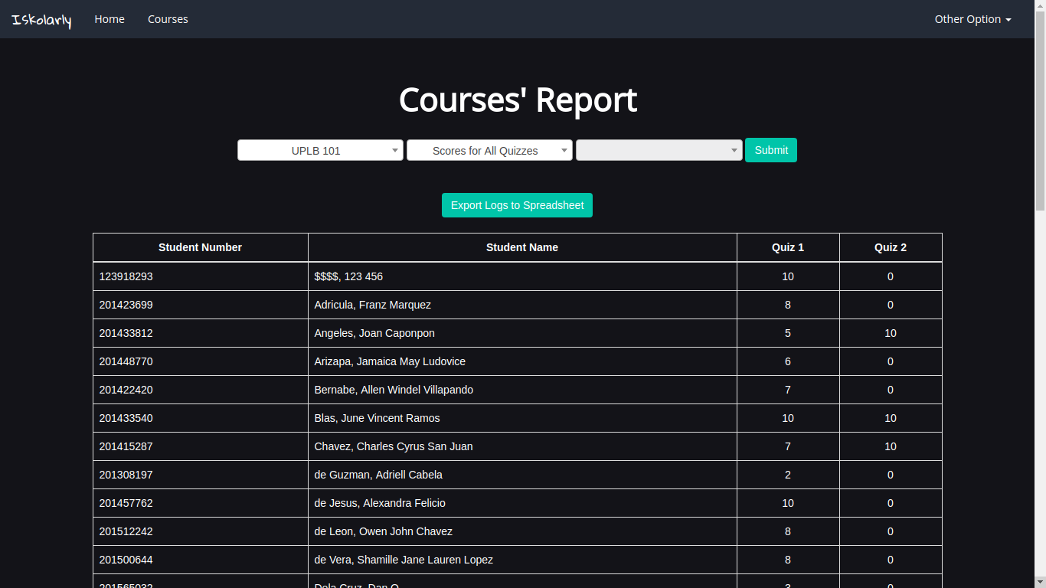

**Step 4:** Select Quiz Summary.  
**Step 5:** Select in the course.

**Step 6**: Click the  
**Submit** button.



**Step 7:** To export the scores, click the **Export logs in spreadsheet.**

1. **Student Module**
2. Creating an account

**Step 1**: Click on the  
 **Sign up** button.

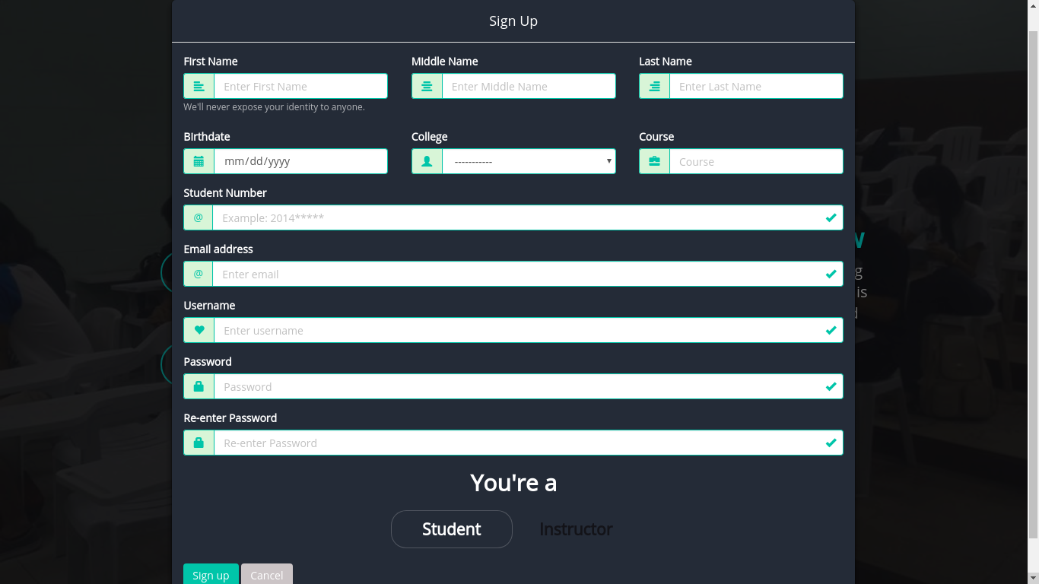

**Step 3**: Click the  
**Sign up** button.

**Step 2**: Select as   
**Student** and  
fill up the form.

1. Joining a course

**Step 1**: Click on the  
 **Sign in** button.

**Step 2**: Fill up the form using valid credentials.



**Step 3**: Click the  
**Sign in** button.



**Step 4:**  
Go to the **Course** menu.

**Step 5**: Click the  
**Add icon** button.

**Step 6**: Enter the class code provided by the instructor.

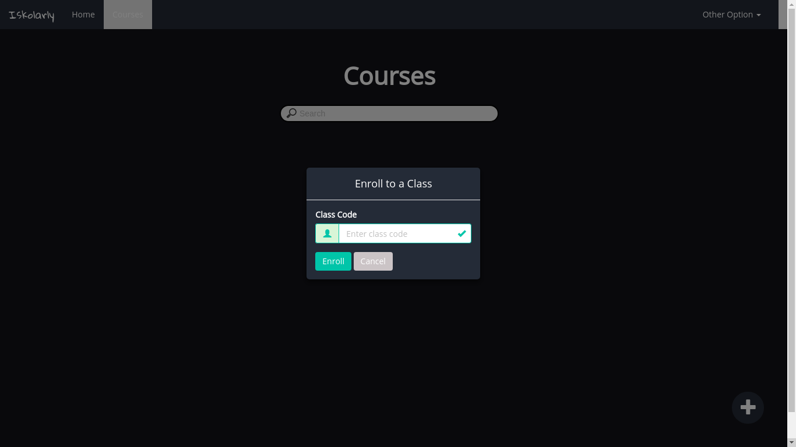

**Step 7**: Click the  
**Enroll** button.

1. Creating posts or announcements, quizzes, and attachments

**Step 1**: Click on the  
 **Sign in** button.

**Step 2**: Fill up the form using valid credentials.



**Step 3**: Click the  
**Sign in** button.

Assuming that student is already joined in a classroom. There are two ways to access the classroom; home menu and course menu.

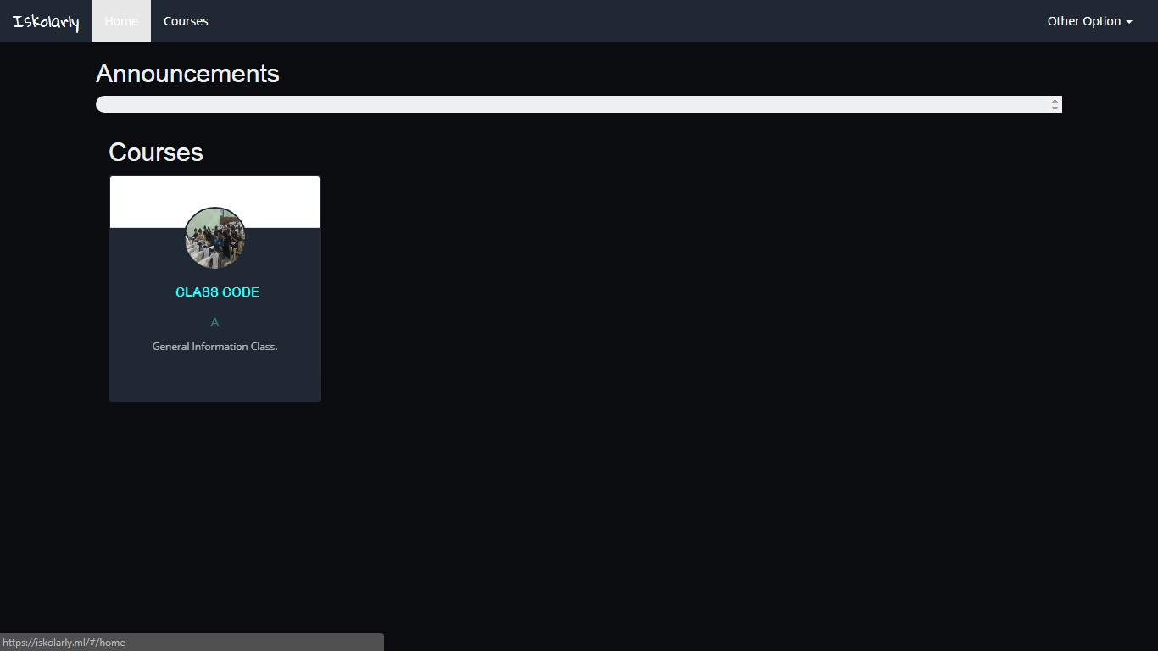

**Step 4**: Click the  
classroomin home page.

**Step 4:**  
Go to the **Course** menu and click the classroom.

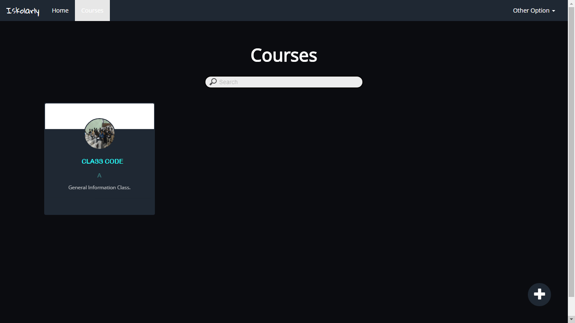

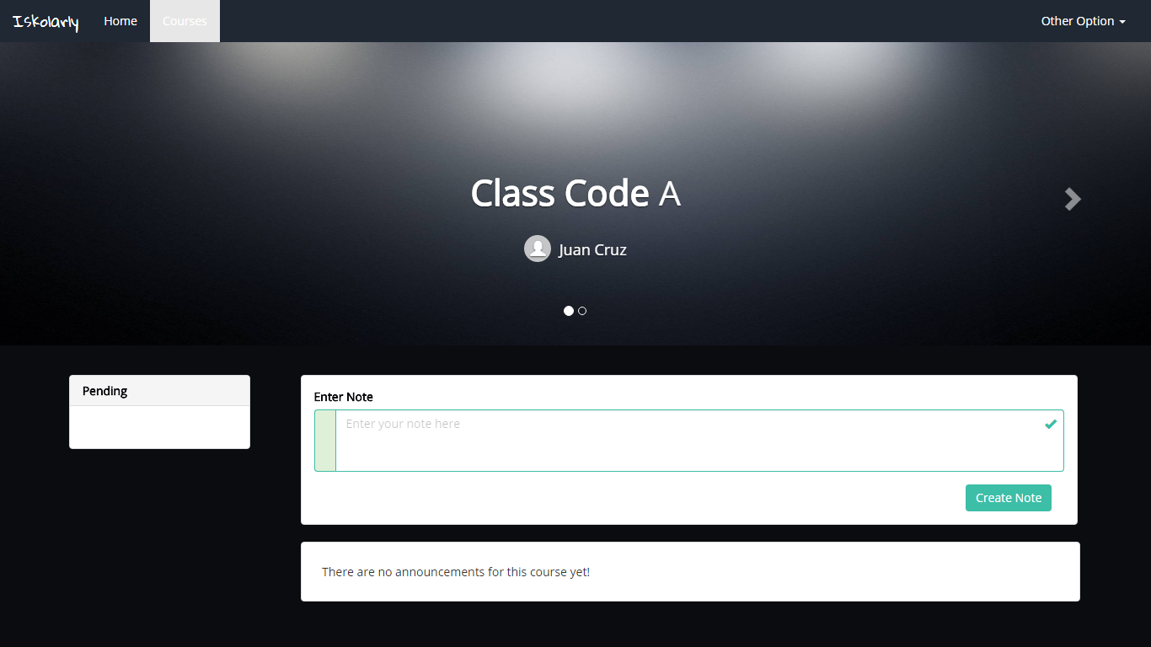

**Step 5**:   
Fill out the field.

**Step 6**: Click the  
**Create note** button.

1. Taking a quiz

**Step 1**: Click on the  
 **Sign in** button.

**Step 2**: Fill up the form using valid credentials.



**Step 3**: Click the  
**Sign in** button.

Assuming that student is already joined in a classroom. There are two ways to access the classroom; home menu and course menu.



**Step 4**: Click the  
classroomin home page.

**Step 4:**  
Go to the **Course** menu and click the classroom.



**Step 5:** Assuming that the instructor already published the quiz.  
Click the quiz post.

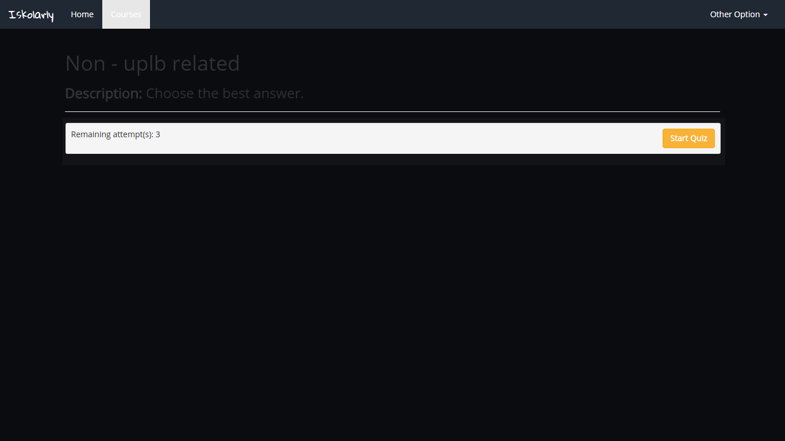

**Step 6**: Click the  
**Start quiz** button to start the quiz attempt.

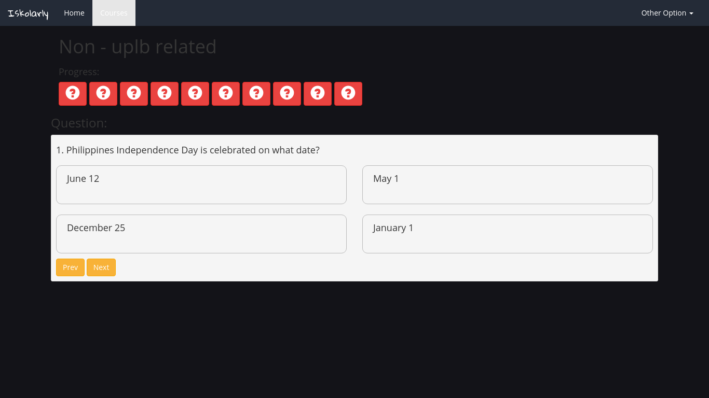

**Step 7**: These are clickable buttons for viewing questions.